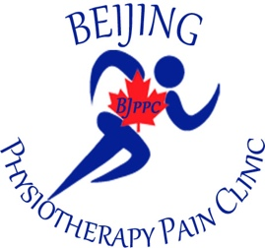
Bei Jing Physiotherapy Pain Clinic
Unit A – 2810 Pembina Highway
Winnipeg, Manitoba R3T 2H8
Tel. No. 204-452-3654
Email: beijingmedicalcentre@shaw.ca
yujingqiu56@gmail.com

AD FOR PHYSIOTHERAPIST:

Bei Jing Physiotherapist Pain Clinic is currently looking to hire a physiotherapist Full-Time or Part-Time, new graduate welcomed.

We are located at Unit A – 2810 Pembina Highway, Winnipeg, Manitoba. R3T 2H8.

Requirements:
- Candidates must be registered and licensed in Manitoba

- Teaching Opportunity available.

Existing physiotherapist moving out of province.

Interested candidates can send their resume to:
Yu Jing Qiu, owner,
Email address yujingqiu56@gmail.com or call 204-229-3376.

Dunia Estella – Clinic Manager
Email beijingmedicalcentre@shaw.ca
Office Tel. No. 204-452-3654

