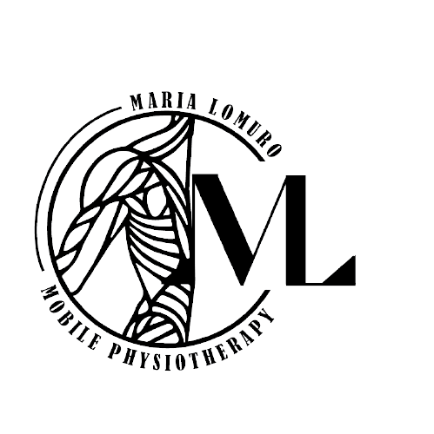

**Love being a physiotherapist but want more flexibility in your day? At Maria Lomuro Mobile Physiotherapy, it is your career, your way.**

We are looking for a registered physiotherapist to join our growing mobile practice on a **permanent part-time basis with the opportunity for full time hours in September 2025**. MLMP has a well-established client base and a waitlist of clients awaiting care. This position is available to start **immediately.** MLMP serves the City of Winnipeg and surrounding areas with the goal of enabling all individuals to access therapy services. We are open to applicants interested in providing care in communities outside of Winnipeg. Our primary focus is supporting individuals as they work to achieve their best quality of life.

**The MLMP Benefit:**

* Excellent work-life balance
* Independent booking options
* Highly competitive compensation
* Electronic charting
* Electronic and direct billing
* Flexible schedule
* Excellent support and training opportunities
* Potential employee structure and extended health benefits
* We do the marketing!

Hours and workdays are negotiable. Desired availability for this listing would include a minimum of two shifts per week. We ensure consistent advertising and marketing continue to engage current and new clientele. We provide a supportive team environment and training opportunities for all our therapists.

We are looking for an energetic, motivated physiotherapist who is comfortable working with

diverse populations in client homes, hospitals, or supported living communities. **The ideal**

**candidate will:**

* Enjoy the opportunity to treat creatively in home environments.
* Require a valid Manitoba driver’s license and access to a vehicle.
* Be in good standing with the **CPM**.
* Hold individual liability insurance.
* Acupuncture, neuro experience, and more than two years as a practicing therapist are assets.

Please email your resume to Maria Lomuro at info@lomurophysiotherapy.com.

**We look forward to hearing from you!**