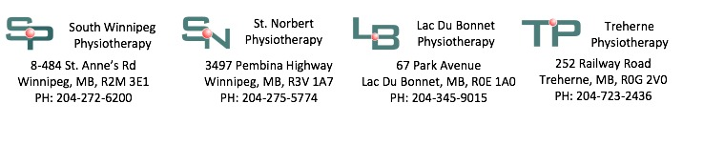

Part Time/Full Time Physiotherapist

We are seeking an entrepreneurial-minded physiotherapist to join our busy Lac du Bonnet clinic!

Qualifications/Requirements:

* Registered Physiotherapist in good standing with the College of Physiotherapists of Manitoba
* Proficiency in assessment, planning, implementing and evaluating patient programs
* Knowledge of best practice standards and patient safety
* Effective written and verbal communication skills
* Strong organizational, time management and problem-solving skills
* Willingness to work within a multi-disciplinary team
* Ability to take initiative and work independently
* Valid driver's license and access to a vehicle

Our Lac du Bonnet clinic is a beautiful, spacious clinic with an existing caseload and strong referral base. Work along side our Athletic therapist, Massage Therapists and next door to our local doctors at the Lac du Bonnet Medical Group.

In conjunction to working at our Lac du Bonnet clinic you will have to opportunity to work with our Athletic Therapists, Occupational Therapist, Physiotherapists and Physical Medicine Doctor at our associate clinics at South Winnipeg Physiotherapy, St. Norbert Physiotherapy and Pathway Rehabilitation.

* We offer a competitive wage structure based on professional experience.
* We support ongoing professional development through educational allowance.
* We foster an environment of professional growth through mentorship and we provide our clinicians with up to date rehabilitation tools and resources.
* We offer a generous travel allowance for commuting to and from our Lac du Bonnet office.

Please submit your cover letter and resume via email to lacdubonnet_physio@mts.net, or drop off in person at 40 Park Avenue in Lac du Bonnet or at our South Winnipeg Physiotherapy office at 484 St. Anne’s Road.

Thank you in advance for your interest in this position.