 ***Get Better. Together.***

**Job description**

A clinic that fosters personal growth and continued support by gaining knowledge from each other to get the best results for our patients

We are located in the neighbourhood of Wolseley, a vibrant area that is centrally located in the city of Winnipeg and close to restaurants, retail and residential areas

We have strong relationships with medical clinics in the area and strong community support based off our combined 25 years of experience

**We will help you get busy and you will love where you work**

**What We Offer:**

Signing bonus ($)

Regular support in maintaining/building caseload ($)

Yearly Incentives ($)

Education allowance $500 in first year. Increases in year 2 and 3 ($)

Free Access to Continuing Education Resources ($)

Onboarding & Training ($)

Health Benefits (if you’re an employee) ($)

Company Sponsored Team Dinners/Events ($)

Free Gym Access ($)

**What Else?**

No admin work. We will do billing and appointments for you.

If you’re an exercise-based therapist: one of the larger rehab areas in the city: 3600 sq ft gym

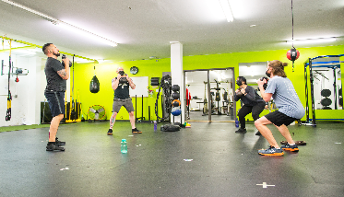 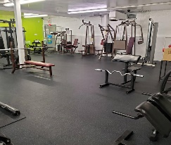 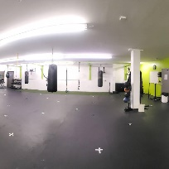

Freedom: We encourage you treat based on the philosophies of your personal vision statement

**Career Path Options:**

1. Focus on your clinic practice and just treat patients

2. Diversify your clinical work and get involved on the business side

*Must be fully licensed in the province of Manitoba and be ready to go.

Job Type: Full-time

Salary: $25.82-$45.00 per hour

Benefits:

* Extended health care
* Flexible schedule
* On-site gym
* On-site parking

Schedule:

* Monday to Friday
* Weekends as needed

Supplemental pay types:

* Signing bonus

Language:

* English (preferred)

Ability to Commute:

* Winnipeg, MB R3C 2B3 (required)

Ability to Relocate:

* Winnipeg, MB R3C 2B3: Relocate before starting work (required)

Work Location: In person

Edit job

Open

View public job page

Top of Form