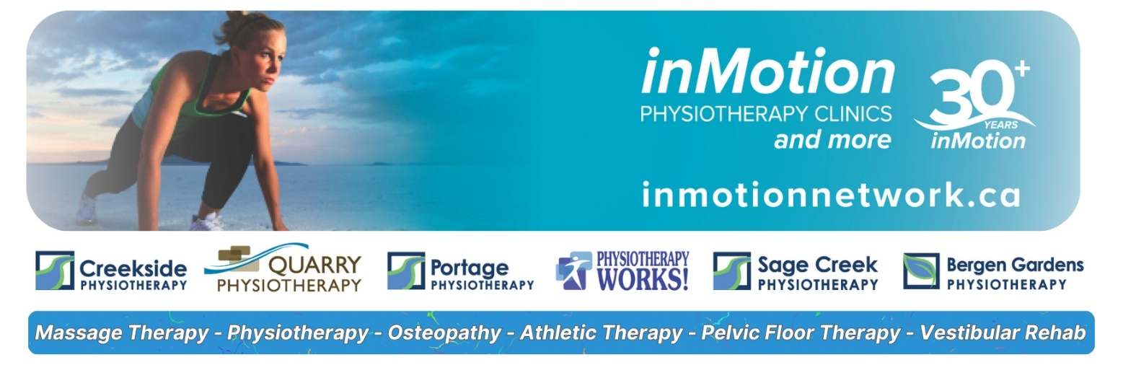

FULL AND/OR PART-TIME PHYSIOTHERAPY POSITIONS AVAILABLE

Steinbach inMotion Physiotherapy

We’re excited to share that the inMotion team has officially expanded to Steinbach with the acquisition of Steinbach Physiotherapy!

We’re looking for passionate, skilled Physiotherapists to join our growing multidisciplinary team. Step into a well-established clinic with a strong existing caseload, collaborative environment, and the support you need to thrive.

Join Our Team at inMotion Physiotherapy and More!
We are seeking dynamic, qualified massage therapists to join our team of rehabilitation specialists. With an extensive caseload already in place, we offer an exciting opportunity to be part of a busy, supportive environment.

Why Join Us?
We offer recently renovated and expanded clinics, well-equipped facilities supported by excellent staff, opportunities for cross-referrals and a team approach to patient management. You will collaborate with experienced physiotherapists, healthcare professionals and specialists with over 30 years of practice and a stellar reputation. There is flexibility to work at one or multiple locations.

- ESTABLISHED CLINICS WITH EXTENSIVE REFERRAL VOLUME
- LARGE CLINICS, RECENTLY RENOVATED & FULLY EQUIPPED
- EXPERIENCED THERAPISTS PROVIDING MENTORSHIP
- EXCELLENT REMUNERATION WITH EXPERIENCE
- ORTHOPAEDIC SKILLSET A REQUIREMENT
- HEALTHY EDUCATIONAL ALLOWANCE
- BENEFIT PLAN

Please contact us in confidence for further information or send your resume attention Scott to scott@inmotionnetwork.ca or call 204-791-2294

Check out our website at www.inmotionnetwork.ca Follow us @inmotionnetwork

