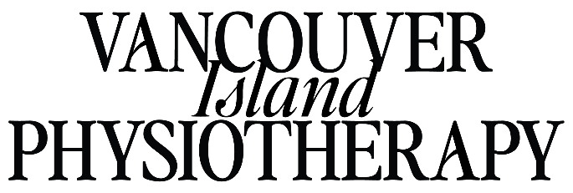
Vancouver Island Physiotherapy is currently seeking a full-time (or part-time) physiotherapist to join our busy private practice in Ladysmith and Cedar on Vancouver Island. The business is a well-established community resource offering dependable allied health services for over twenty years through our two community clinics.
The team at Vancouver Island Physiotherapy is a group of welcoming professionals that work in unison to provide the best care possible for our patients while supporting each other’s development. We are a multi-disciplinary team of physiotherapists, chiropractors, acupuncturists, and PBT laser therapists. Our clinic treats a wide range of clients from orthopaedics and neurology to pediatrics and women’s health. We are looking for a candidate who is innovative, with a passion for the profession. Do you have a particular area of physiotherapy you love to treat? Let’s connect you with your ideal patient caseload and watch your practice advance! Joining our team of professionals will provide your career with the support and mentorship that you desire as you develop your practice in the years ahead, both for recent graduates and seasoned professionals.
What to expect:
- Diverse and varied caseload making your work dynamic and challenging: pediatrics to geriatric, local weekend warrior to sponsored athletes, neurology to oncology.
- Flexible hours and competitive wages, we value your work-life balance!
- Excellent client and specialist referral which means you build a caseload quick and you stay busy!
- Private treatment rooms with ocean views for your one-on-one treatment sessions.
- A welcoming, worry-free environment; our front-end staff support your booking and billing needs and manage changing schedules.
- In-house FCAMPT mentoring for indirect and direct hours.
- Employee events, community support, team building, training and mentorship.
If you haven’t already started packing your bags, here is more! Vancouver Island is a growing community and offers opportunities and affordable growth for young families and new graduates starting out. As the island continues to grow, affordable housing continues to be a reason to choose Island living in a location that is urban but with a close-knit community feel. The Island offers no shortage of hiking, surfing, and winter sports, in addition to the recent and improved connectivity to the mainland for further away vacations and travels from YVR. Come to build your career while enjoying the west coast climate that promotes and allows more activity throughout the year.
Please send your questions and CV to Erika at erika@viphysiotherapy.com and we look forward to welcoming you to our team in 2025! We thank you for your interest in Vancouver Island Physiotherapy.

